My first artifact is the Computational Graphics and Visualization ShapeMeshes.cpp enhancement from CS 330. It is an OpenGL program that transforms a 2D image into a 3D texture environment. This project was worked on throughout the beginning of January and the end of February 2025. The artifact is composed of loading textures, creating lighting, and building 3D shapes to display a realistic environment in OpenGL.

I selected this item because it showcases software and design by replicating a real-life image into C++ 3D objects through Visual Studio. During the creation of this project, I experimented a lot with the lighting and texture components for each object created. My skills and abilities were best shown in the transformation of all the 3D objects’ placement. Recreating the image led to the most tests and when improving it, the new objects also allowed me to experiment more with the environment. I was able to apply new textures and lighting to the objects and set up a background and a third ambient light. While coding I also cleaned the organization of the code overall to have more clarity.

Some of the course outcomes I have met in this Module are designing and evaluating computing solutions that solve a given problem using algorithmic principles and computer science practices, as well as demonstrating innovative techniques, skills, and tools to implement these computer solutions. The skills shown during this artifact are problem-solving and development of design. I was able to go through the development process of each object and add new details while creating additional objects for a realistic 3D scene.

While modifying the artifact, I learned more about the transformations needed to replicate the basketball hoop as 3D objects with texture and the backgrounds with texture. I added an extra bird toy as represented in my original 2D image; however, this process took some time with gathering the new texture files and moving the objects to their correct placement. One challenge I did face was lighting, I was aiming for a nice sunset light with a mixture of yellow and orange. While I did manage to create this ambiance on the first try, I began to change the lighting and details of the object to reflect a more outside environment. I also noticed that one of the background textures is darker than the other two, I applied material lighting onto the object, but it did not make any difference after a couple of attempts. As I cleaned up the textures and added more details, I found the image was clearer and had a better surrounding environment than before. (1st attempt: Left Picture) (2nd attempt: Right Picture) A video game screen with objects on the ground
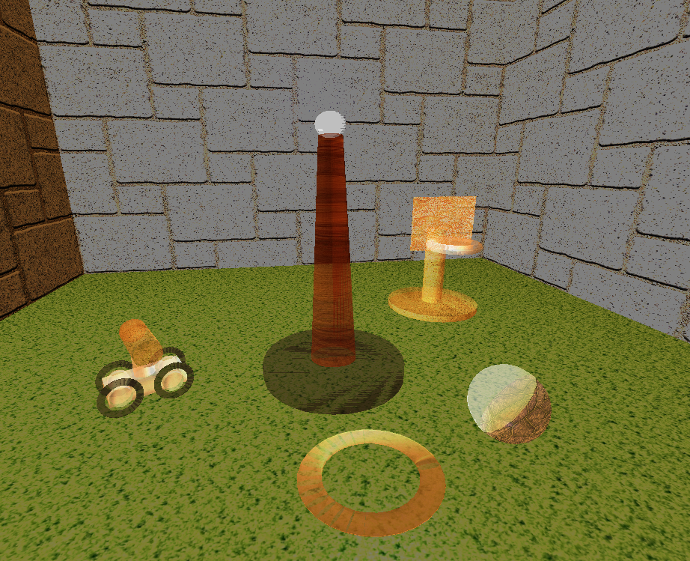

Most of the changes lie under the RenderScene() Method and the SetupSceneLights() Method; I focused on both course outcomes for improvement. While developing the enhancement, I also worked on oral and visual communications that delivered the main idea of the product and the design choices. I met all three course outcomes, even with a couple of obstacles along the way. As mentioned before, the challenge of this enhancement was the lighting, as I experimented with different ambient backgrounds:

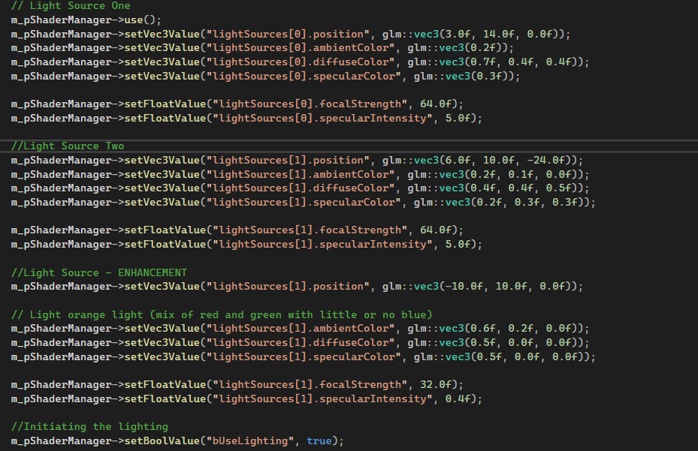

The outcome of the lighting and the texture of each object did not reach the outcome I aimed for but came close to the desired environment. Each feature allowed me to reflect on the enhancement and how the 3D scene could be improved. Within my research, I learned more about shading, ambient lighting, and light sources in OpenGL.